IT-SIMPLERA INSTITUTE

Network Administration Internship Program
WEEK 02 LAB REPORT
Submitted By | Muhammad ismail
Submitted to | Jawad Qayum — Senior Network Administrator
Department | Network Administration
Institute | IT-Simplera Institute
Week | 02
Submission Deadline | 10 July 2026
Tools Used | Cisco Packet Tracer, GNS3

Title:-
IP Addressing (FLSM & VLSM) and VLAN Configuration using Cisco Packet Tracer and GNS3
Objectives:-
- To understand the concept of Fixed Length Subnet Masking (FLSM).
- To understand the concept of Variable Length Subnet Masking (VLSM).
- To calculate network addresses, subnet masks, broadcast addresses, and host ranges.
- To learn efficient IP address allocation techniques.
- To understand the purpose and benefits of VLANs.
- To configure VLANs in Cisco Packet Tracer.
- To configure VLANs in GNS3.
- To configure Access Ports and Trunk Ports.
- To verify VLAN operation using Cisco IOS commands.
- To improve practical networking and troubleshooting skills.

Background Theory
Fixed Length Subnet Masking (FLSM):-
Fixed Length Subnet Masking (FLSM) is a subnetting technique where all subnets use the same subnet mask. Every subnet contains the same number of hosts. FLSM is simple to design and manage but may waste IP addresses because all networks receive equal-sized address blocks.
Advantages of FLSM
- Easy to configure.
- Simple network management.
- Suitable for networks with equal host requirements.
Disadvantages of FLSM
- Wastage of IP addresses.
- Less flexibility.
Variable Length Subnet Masking (VLSM):-
Variable Length Subnet Masking (VLSM) allows different subnet masks within the same network. It allocates IP addresses according to actual host requirements.
Advantages of VLSM
- Efficient use of IP addresses.
- Flexible network design.
- Suitable for enterprise networks.
Disadvantages of VLSM
- More complex calculations.
- Requires careful planning.
Virtual Local Area Network (VLAN):-
A VLAN is a logical division of a network that separates devices into different broadcast domains regardless of their physical location.
Benefits of VLANs
- Improved security.
- Reduced broadcast traffic.
- Better network performance.
- Easier management.
- Increased scalability.

FLSM Questions with Solutions
Question 1:-

Network: 192.168.1.0/24
Problem 1: 192.168.1.0/24, divided into 4 equal subnets
Bits borrowed: 2 | New subnet mask: /26 (255.255.255.192) | Usable hosts per subnet: 62
Subnet # | Network Address | Usable Host Range | Broadcast Address
1 | 192.168.1.0 | 192.168.1.1 - 192.168.1.62 | 192.168.1.63
2 | 192.168.1.64 | 192.168.1.65 - 192.168.1.126 | 192.168.1.127
3 | 192.168.1.128 | 192.168.1.129 - 192.168.1.190 | 192.168.1.191
4 | 192.168.1.192 | 192.168.1.193 - 192.168.1.254 | 192.168.1.255

Problem 2: 172.16.0.0/16, divided into 8 equal subnets
Bits borrowed: 3 | New subnet mask: /19 (255.255.224.0) | Usable hosts per subnet: 8,190
Subnet # | Network Address | Usable Host Range | Broadcast Address
1 | 172.16.0.0 | 172.16.0.1 - 172.16.31.254 | 172.16.31.255
2 | 172.16.32.0 | 172.16.32.1 - 172.16.63.254 | 172.16.63.255
3 | 172.16.64.0 | 172.16.64.1 - 172.16.95.254 | 172.16.95.255
4 | 172.16.96.0 | 172.16.96.1 - 172.16.127.254 | 172.16.127.255
5 | 172.16.128.0 | 172.16.128.1 - 172.16.159.254 | 172.16.159.255
6 | 172.16.160.0 | 172.16.160.1 - 172.16.191.254 | 172.16.191.255
7 | 172.16.192.0 | 172.16.192.1 - 172.16.223.254 | 172.16.223.255
8 | 172.16.224.0 | 172.16.224.1 - 172.16.255.254 | 172.16.255.255

Problem 3: 10.0.0.0/8, divided into 16 equal subnets
Bits borrowed: 4 | New subnet mask: /12 (255.240.0.0) | Usable hosts per subnet: 1,048,574
Subnet # | Network Address | Usable Host Range | Broadcast Address
1 | 10.0.0.0 | 10.0.0.1 - 10.15.255.254 | 10.15.255.255
2 | 10.16.0.0 | 10.16.0.1 - 10.31.255.254 | 10.31.255.255
3 | 10.32.0.0 | 10.32.0.1 - 10.47.255.254 | 10.47.255.255
4 | 10.48.0.0 | 10.48.0.1 - 10.63.255.254 | 10.63.255.255
... | (pattern repeats in blocks of 16 in 2nd octet) | ... | ...
16 | 10.240.0.0 | 10.240.0.1 - 10.255.255.254 | 10.255.255.255

Problem 4: 192.168.20.0/24, divided into 2 equal subnets
Bits borrowed: 1 | New subnet mask: /25 (255.255.255.128) | Usable hosts per subnet: 126
Subnet # | Network Address | Usable Host Range | Broadcast Address
1 | 192.168.20.0 | 192.168.20.1 - 192.168.20.126 | 192.168.20.127
2 | 192.168.20.128 | 192.168.20.129 - 192.168.20.254 | 192.168.20.255

Problem 5: 192.168.50.0/24, divided into 16 equal subnets
Bits borrowed: 4 | New subnet mask: /28 (255.255.255.240) | Usable hosts per subnet: 14
Subnet # | Network Address | Usable Host Range | Broadcast Address
1 | 192.168.50.0 | 192.168.50.1 - 192.168.50.14 | 192.168.50.15
2 | 192.168.50.16 | 192.168.50.17 - 192.168.50.30 | 192.168.50.31
3 | 192.168.50.32 | 192.168.50.33 - 192.168.50.46 | 192.168.50.47
4 | 192.168.50.48 | 192.168.50.49 - 192.168.50.62 | 192.168.50.63
... | (pattern repeats in blocks of 16) | ... | ...
16 | 192.168.50.240 | 192.168.50.241 - 192.168.50.254 | 192.168.50.255

Problem 6: 172.20.0.0/16, divided into 4 equal subnets
Bits borrowed: 2 | New subnet mask: /18 (255.255.192.0) | Usable hosts per subnet: 16,382
Subnet # | Network Address | Usable Host Range | Broadcast Address
1 | 172.20.0.0 | 172.20.0.1 - 172.20.63.254 | 172.20.63.255
2 | 172.20.64.0 | 172.20.64.1 - 172.20.127.254 | 172.20.127.255
3 | 172.20.128.0 | 172.20.128.1 - 172.20.191.254 | 172.20.191.255
4 | 172.20.192.0 | 172.20.192.1 - 172.20.255.254 | 172.20.255.255

Problem 7: 10.10.0.0/16, divided into 32 equal subnets
Bits borrowed: 5 | New subnet mask: /21 (255.255.248.0) | Usable hosts per subnet: 2,046
Subnet # | Network Address | Usable Host Range | Broadcast Address
1 | 10.10.0.0 | 10.10.0.1 - 10.10.7.254 | 10.10.7.255
2 | 10.10.8.0 | 10.10.8.1 - 10.10.15.254 | 10.10.15.255
3 | 10.10.16.0 | 10.10.16.1 - 10.10.23.254 | 10.10.23.255
4 | 10.10.24.0 | 10.10.24.1 - 10.10.31.254 | 10.10.31.255
... | (pattern repeats in blocks of 8 in 3rd octet) | ... | ...
32 | 10.10.248.0 | 10.10.248.1 - 10.10.255.254 | 10.10.255.255

Problem 8: 192.168.100.0/24, divided into 8 equal subnets
Bits borrowed: 3 | New subnet mask: /27 (255.255.255.224) | Usable hosts per subnet: 30
Subnet # | Network Address | Usable Host Range | Broadcast Address
1 | 192.168.100.0 | 192.168.100.1 - 192.168.100.30 | 192.168.100.31
2 | 192.168.100.32 | 192.168.100.33 - 192.168.100.62 | 192.168.100.63
3 | 192.168.100.64 | 192.168.100.65 - 192.168.100.94 | 192.168.100.95
4 | 192.168.100.96 | 192.168.100.97 - 192.168.100.126 | 192.168.100.127
5 | 192.168.100.128 | 192.168.100.129 - 192.168.100.158 | 192.168.100.159
6 | 192.168.100.160 | 192.168.100.161 - 192.168.100.190 | 192.168.100.191
7 | 192.168.100.192 | 192.168.100.193 - 192.168.100.222 | 192.168.100.223
8 | 192.168.100.224 | 192.168.100.225 - 192.168.100.254 | 192.168.100.255

Problem 9: 172.31.0.0/16, divided into 2 equal subnets
Bits borrowed: 1 | New subnet mask: /17 (255.255.128.0) | Usable hosts per subnet: 32,766
Subnet # | Network Address | Usable Host Range | Broadcast Address
1 | 172.31.0.0 | 172.31.0.1 - 172.31.127.254 | 172.31.127.255
2 | 172.31.128.0 | 172.31.128.1 - 172.31.255.254 | 172.31.255.255

Problem 10: 10.20.30.0/24, divided into 4 equal subnets
Bits borrowed: 2 | New subnet mask: /26 (255.255.255.192) | Usable hosts per subnet: 62
Subnet # | Network Address | Usable Host Range | Broadcast Address
1 | 10.20.30.0 | 10.20.30.1 - 10.20.30.62 | 10.20.30.63
2 | 10.20.30.64 | 10.20.30.65 - 10.20.30.126 | 10.20.30.127
3 | 10.20.30.128 | 10.20.30.129 - 10.20.30.190 | 10.20.30.191
4 | 10.20.30.192 | 10.20.30.193 - 10.20.30.254 | 10.20.30.255

VLSM Worksheet — 5 Scenarios
Allocation method: list all host requirements in descending order, calculate the smallest block that satisfies each (2^n − 2 ≥ required hosts), then assign subnets sequentially from the start of the base network so no address space is wasted between allocations.

Scenario 1: Base Network 192.168.1.0/24
Segment | Hosts Req. | Mask (CIDR) | Network Address | Usable Host Range | Broadcast Address
Sales | 50 | /26 | 192.168.1.0 | 192.168.1.1 - 192.168.1.62 | 192.168.1.63
HR | 25 | /27 | 192.168.1.64 | 192.168.1.65 - 192.168.1.94 | 192.168.1.95
IT | 10 | /28 | 192.168.1.96 | 192.168.1.97 - 192.168.1.110 | 192.168.1.111
Guest Wi-Fi | 5 | /29 | 192.168.1.112 | 192.168.1.113 - 192.168.1.118 | 192.168.1.119
Router-Router WAN Link | 2 | /30 | 192.168.1.120 | 192.168.1.121 - 192.168.1.122 | 192.168.1.123

Scenario 2: Base Network 172.16.0.0/24
Segment | Hosts Req. | Mask (CIDR) | Network Address | Usable Host Range | Broadcast Address
Department A | 100 | /25 | 172.16.0.0 | 172.16.0.1 - 172.16.0.126 | 172.16.0.127
Department B | 50 | /26 | 172.16.0.128 | 172.16.0.129 - 172.16.0.190 | 172.16.0.191
Department C | 20 | /27 | 172.16.0.192 | 172.16.0.193 - 172.16.0.222 | 172.16.0.223
Department D | 10 | /28 | 172.16.0.224 | 172.16.0.225 - 172.16.0.238 | 172.16.0.239
Address range 172.16.0.240/28 (16 addresses) remains unused / reserved for future growth.

Scenario 3: Base Network 10.0.1.0/24
Segment | Hosts Req. | Mask (CIDR) | Network Address | Usable Host Range | Broadcast Address
Floor 1 | 60 | /26 | 10.0.1.0 | 10.0.1.1 - 10.0.1.62 | 10.0.1.63
Floor 2 | 30 | /27 | 10.0.1.64 | 10.0.1.65 - 10.0.1.94 | 10.0.1.95
Floor 3 | 14 | /28 | 10.0.1.96 | 10.0.1.97 - 10.0.1.110 | 10.0.1.111
Inter-Router Link | 2 | /30 | 10.0.1.112 | 10.0.1.113 - 10.0.1.114 | 10.0.1.115

Scenario 4: Base Network 192.168.5.0/24
Segment | Hosts Req. | Mask (CIDR) | Network Address | Usable Host Range | Broadcast Address
R&D | 40 | /26 | 192.168.5.0 | 192.168.5.1 - 192.168.5.62 | 192.168.5.63
Finance | 20 | /27 | 192.168.5.64 | 192.168.5.65 - 192.168.5.94 | 192.168.5.95
Admin | 10 | /28 | 192.168.5.96 | 192.168.5.97 - 192.168.5.110 | 192.168.5.111
Server Farm | 6 | /29 | 192.168.5.112 | 192.168.5.113 - 192.168.5.118 | 192.168.5.119
WAN Link | 2 | /30 | 192.168.5.120 | 192.168.5.121 - 192.168.5.122 | 192.168.5.123

Scenario 5: Base Network 172.20.10.0/24
Segment | Hosts Req. | Mask (CIDR) | Network Address | Usable Host Range | Broadcast Address
Building A | 70 | /25 | 172.20.10.0 | 172.20.10.1 - 172.20.10.126 | 172.20.10.127
Building B | 35 | /26 | 172.20.10.128 | 172.20.10.129 - 172.20.10.190 | 172.20.10.191
Building C | 15 | /27 | 172.20.10.192 | 172.20.10.193 - 172.20.10.222 | 172.20.10.223
Building D | 6 | /29 | 172.20.10.224 | 172.20.10.225 - 172.20.10.230 | 172.20.10.231
Inter-Router Link | 2 | /30 | 172.20.10.232 | 172.20.10.233 - 172.20.10.234 | 172.20.10.235

Cisco Packet Tracer topology: -
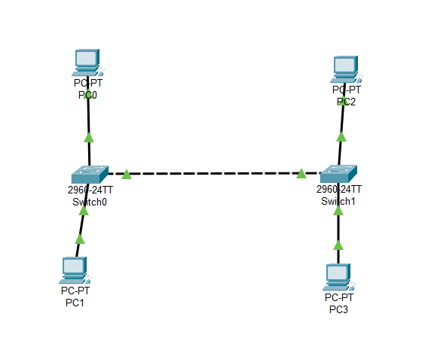
Switch 0:-
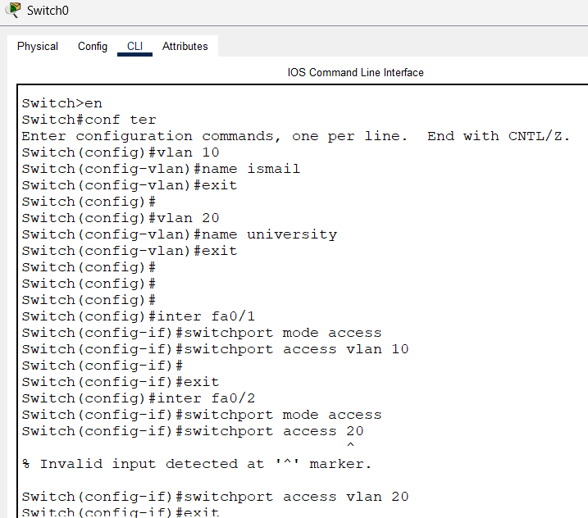
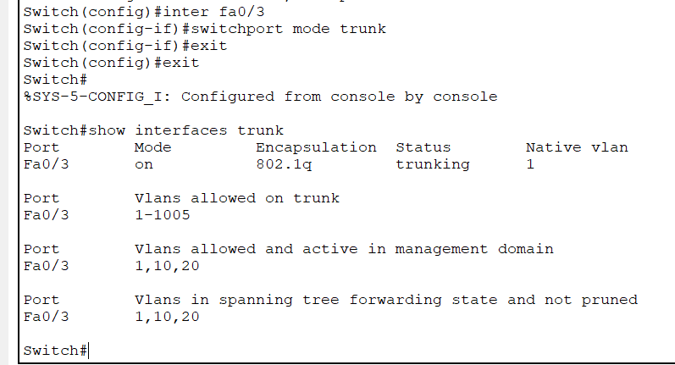
show interfaces trunk:-
is used to verify whether the link between Switch0 and Switch1 is configured as a trunk.

Now show VLANs:-
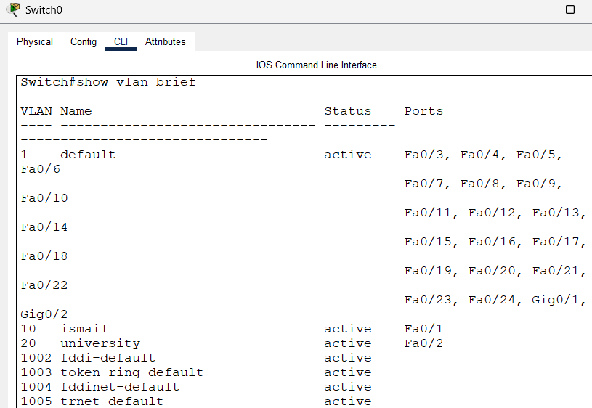

Now switch 1:-
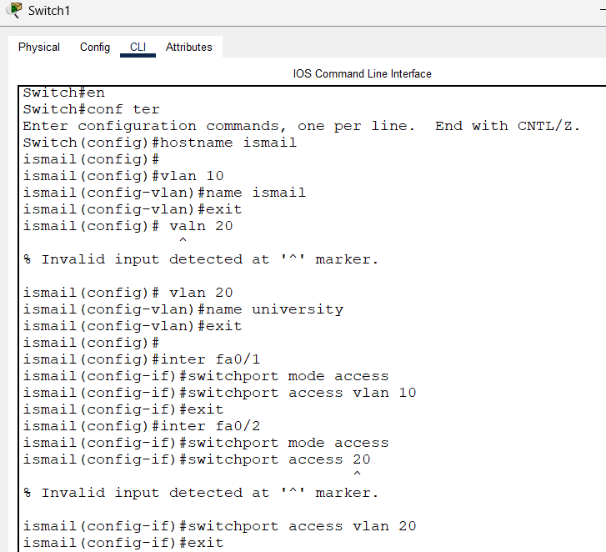

Now show VLANs:-
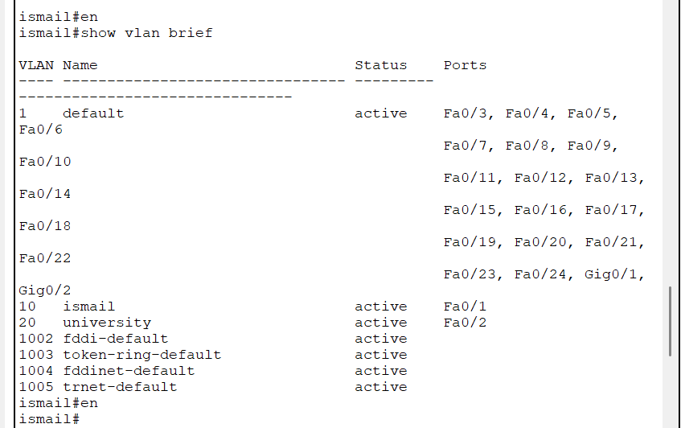
show interfaces trunk:-
is used to verify whether the link between Switch0 and Switch1 is configured as a trunk.
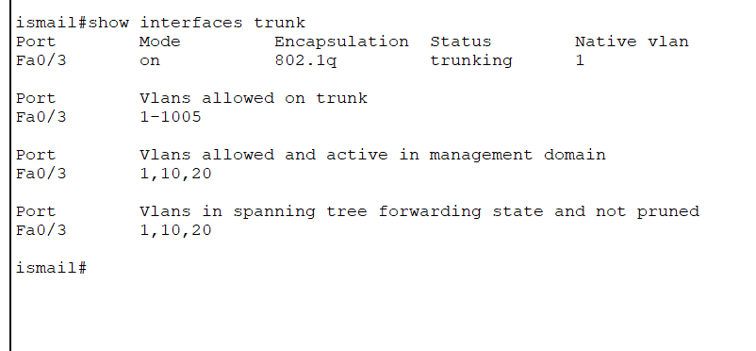

GNS3 topology: -
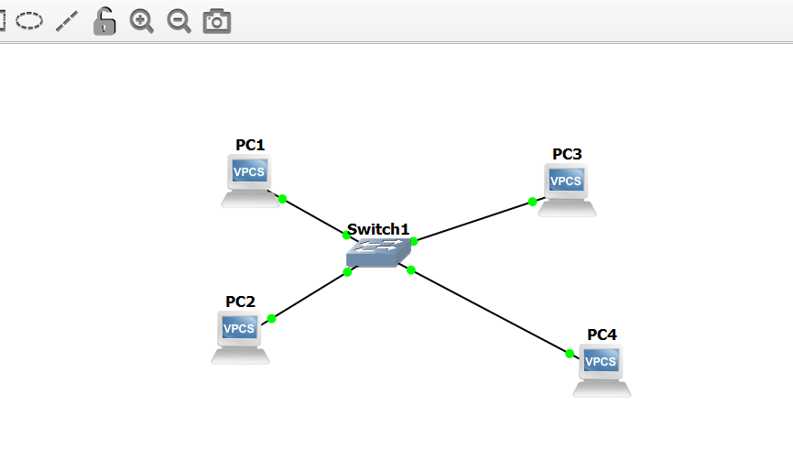
Switch CLI:-
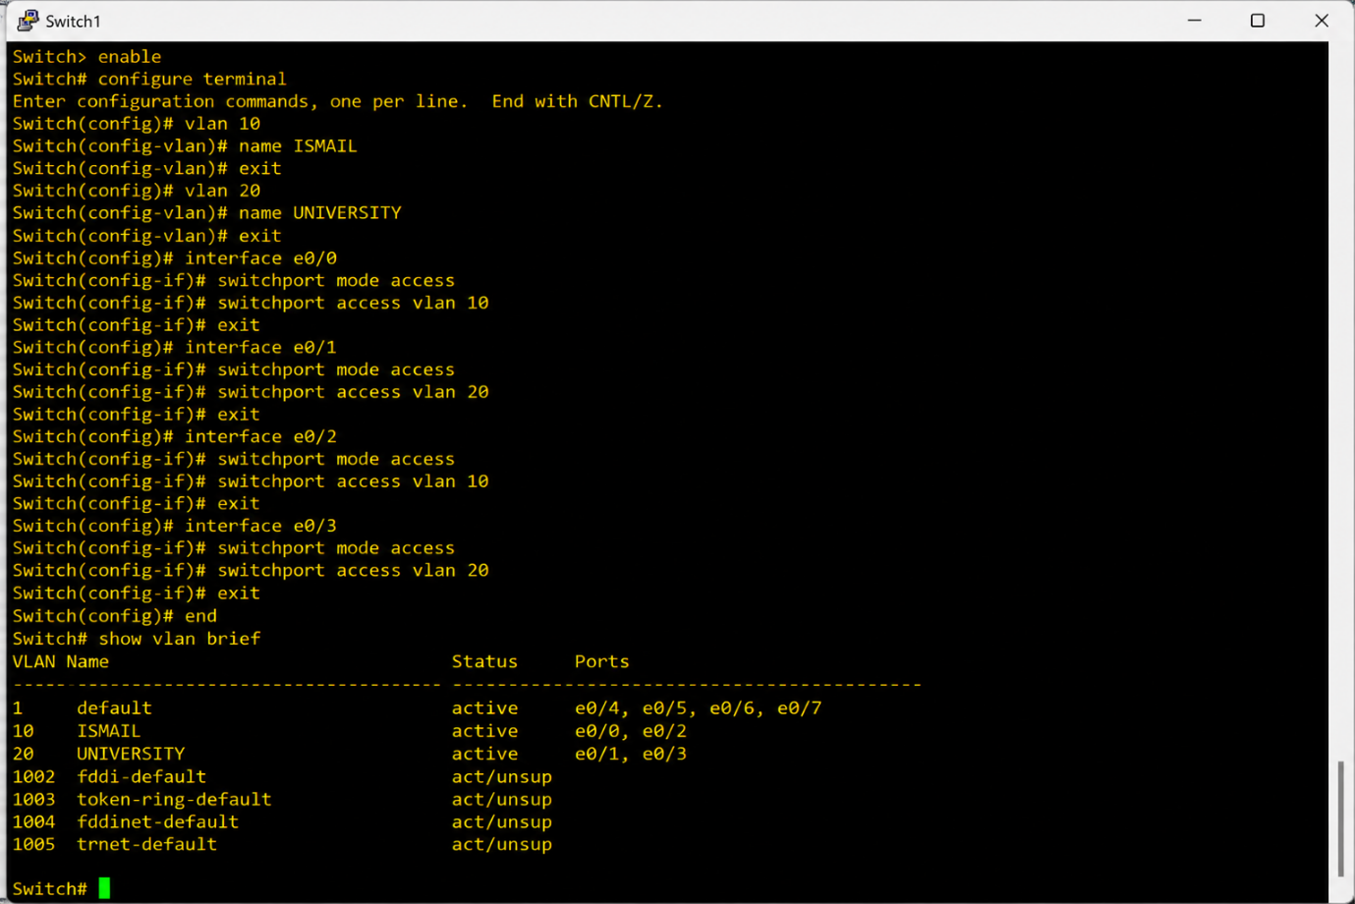
Ping Verification:-
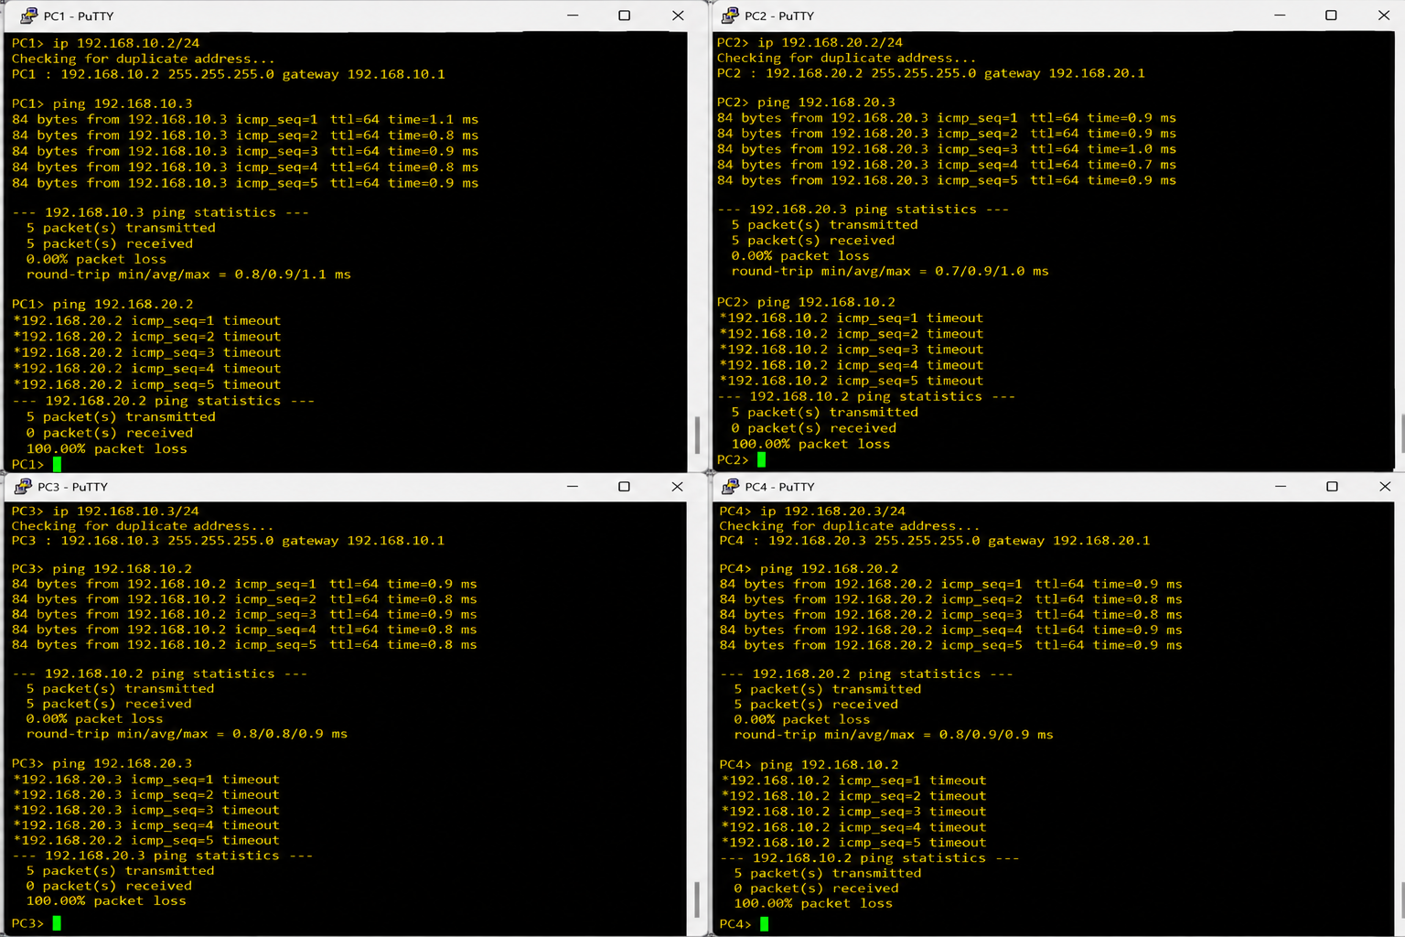




Conclusion:-
This lab provided practical experience in IP addressing and VLAN implementation. FLSM and VLSM techniques were used to design efficient IP addressing schemes, while VLAN configuration was performed in Cisco Packet Tracer and GNS3. Network connectivity was verified through IOS commands and ping tests. The lab enhanced understanding of network segmentation, address management, and enterprise network configuration.

